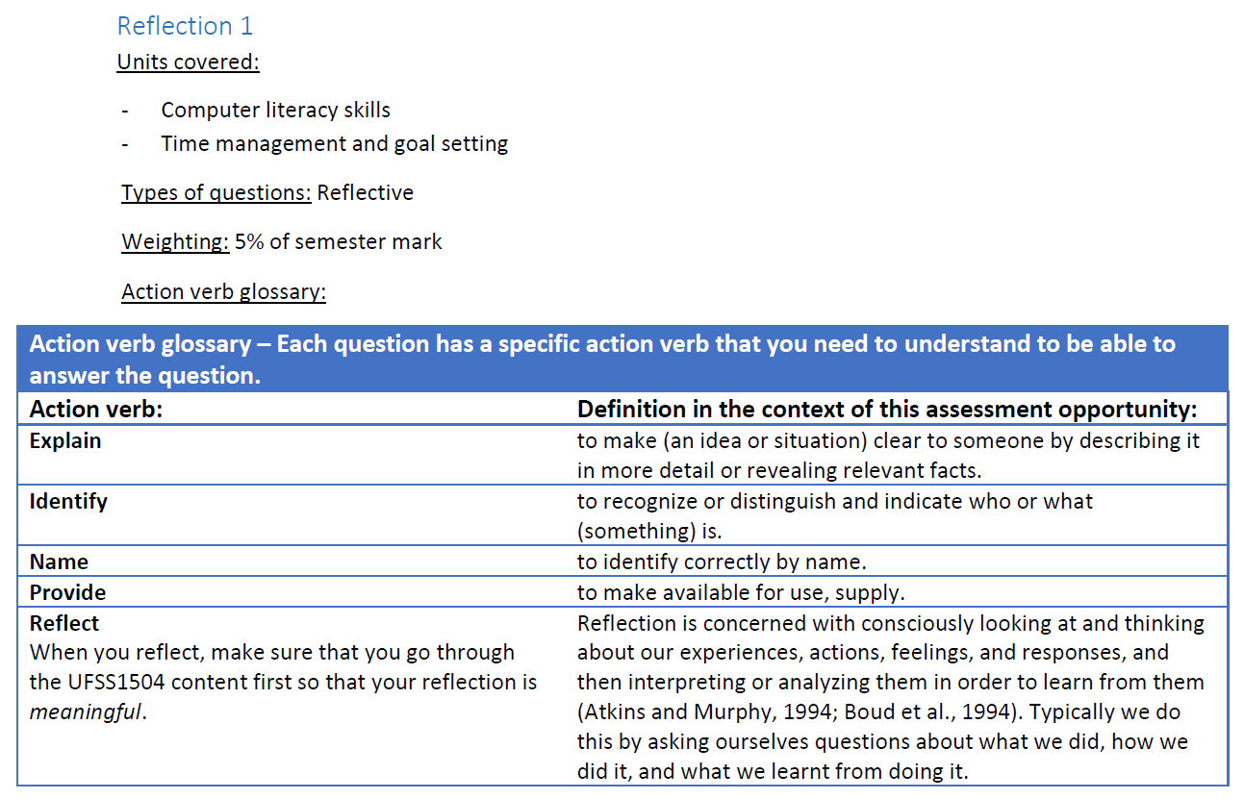

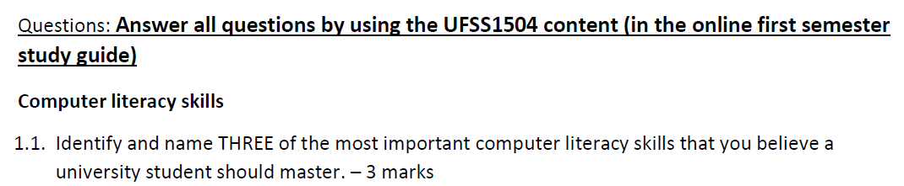

* 

|  |
| --- |
| Delete this grey text and write your answer(s) here. |



|  |
| --- |
| Delete this grey text and write your answer(s) here. |

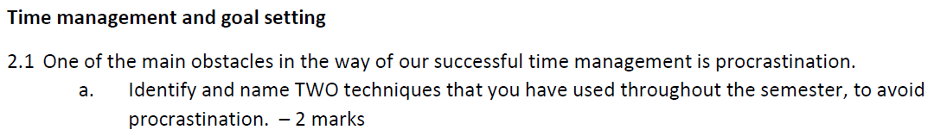

|  |
| --- |
| Delete this grey text and write your answer(s) here. |



|  |
| --- |
| Delete this grey text and write your answer(s) here. |



|  |
| --- |
| Delete this grey text and write your answer(s) here. |



|  |
| --- |
| Delete this grey text and write your answer(s) here. |



|  |
| --- |
| Delete this grey text and write your answer(s) here. |

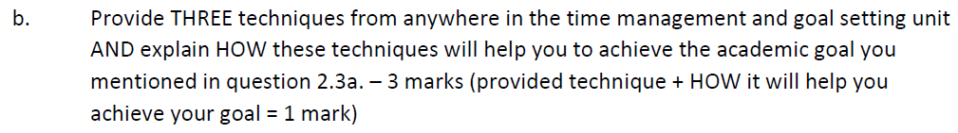

|  |
| --- |
| Delete this grey text and write your answer(s) here. |

